Name: M Shan Iftikhar

Roll No: BSAI-4A-017

Lab task 7, 8

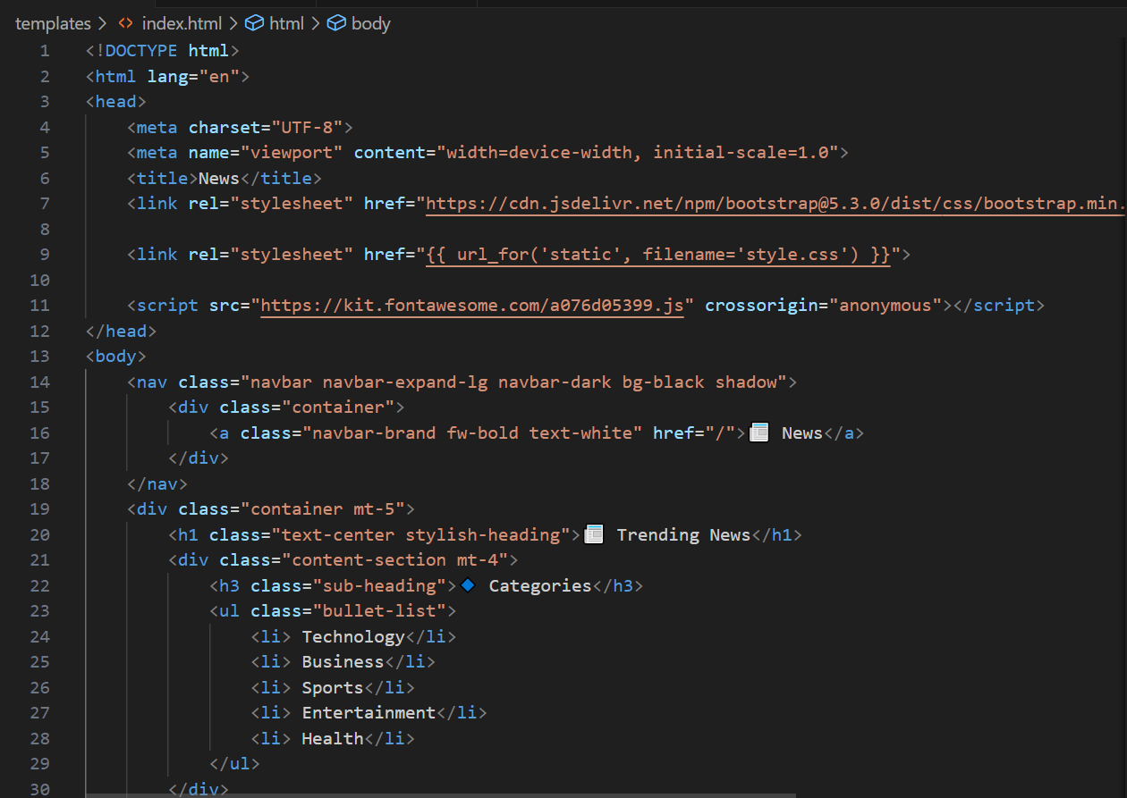

News App

A **News Application** using **Flask**, a lightweight Python web framework. The application will fetch the latest top headlines from **NewsAPI** and display them on a web interface. The project will include both a **backend API endpoint** to fetch live news data and a **frontend web page** to showcase the news articles in a user-friendly manner.

**Technologies Used**

1. **Flask (Python Web Framework)**:
   * Used to build the web application and handle routing, requests, and responses.
2. **HTML & CSS (with Bootstrap for Styling)**:
   * Used to create and style the frontend web interface, ensuring a clean and responsive design.
3. **NewsAPI**:
   * A third-party API used to fetch the latest news headlines from various sources.

**Code Implementation**

**app.py (Main Flask Application)**

This file contains the core logic of the application. Here's a breakdown of its functionality:

1. **Flask Setup**:
   * Flask: The main framework used to create the web application.
   * render_template: Renders HTML templates (like index.html) to display content on the web interface.
   * jsonify: Converts Python data structures (e.g., lists or dictionaries) into JSON format, which is useful for API responses.
   * requests: Used to make HTTP requests to fetch live news data from NewsAPI.
2. **Initializing the Flask Application**:
   * app = Flask(__name__): Initializes the Flask application instance.
   * API_KEY: A unique API key is required to authenticate and fetch data from NewsAPI.
3. **Fetching News Data from NewsAPI**:
   * The API request URL is constructed using the API key.
   * A GET request is sent to fetch the top news headlines.
   * The JSON response is parsed, and the articles are extracted and returned as a list.
4. **API Endpoint for News Data**:
   * A Flask route /news is defined to handle GET requests.
   * The get_news() function fetches the latest news articles and returns them as a JSON response.
5. **Rendering the Home Page**:
   * The route / is defined for the home page.
   * It fetches the latest news articles using get_news() and passes them to the index.html template for display.
6. **Running the Application**:
   * The app runs only when executed directly (not when imported as a module).
   * The debug=True mode is enabled for easier troubleshooting and development.

**Frontend Design (HTML & CSS)**

The frontend is designed to be clean, responsive, and user-friendly using **Bootstrap**. Here's how the page is structured:

1. **Navigation Bar**:
   * Displays the app name and links to the homepage.
2. **Content Sections**:
   * Displays categories like **Technology**, **Business**, and **Health** in bullet points, giving users a quick overview of the available news options.
3. **News Articles**:
   * Each article is displayed as a **card** with:
     + An image (if available).
     + A title.
     + A short description.
     + A **"Read More"** button linking to the full article.

**Key Features**

1. **Dynamic News Fetching**:
   * The app fetches the latest news headlines in real-time from NewsAPI.
2. **API Endpoint**:
   * The /news endpoint provides a JSON response with the latest news articles, making it easy to integrate with other applications.
3. **Responsive Design**:
   * The frontend is designed using Bootstrap, ensuring the application looks great on all devices (desktop, tablet, and mobile).
4. **User-Friendly Interface**:
   * The news articles are displayed in a clean and organized manner, making it easy for users to browse and read the latest news.